Create and Send a Bulk Message

When to use a bulk message
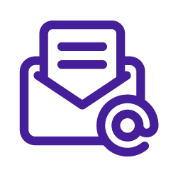
Use a bulk message when you want to send one email to many recipients at one time, and the content is mostly the same for everyone, with only light personalization, such as merge fields.
If you need reminders, branching logic, or follow-up steps, build a cadence instead.
Watch this full video on how to create and send a bulk message.

Steps

1. Open Bulk Messages and create a new bulk message
Go to Cadences 2.0 and open Bulk Messages. Start a new bulk message to launch the setup flow.
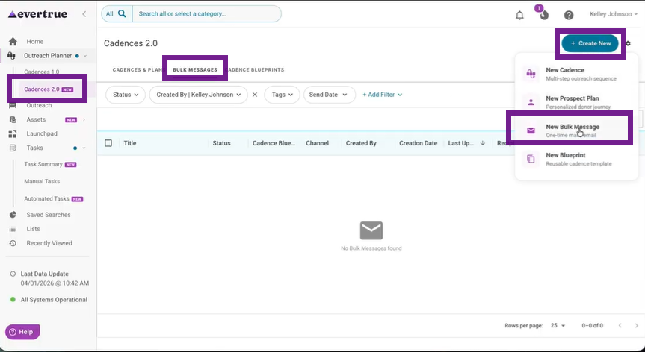

2. Complete the Message Content step
Enter or review the sender email, sender name, reply-to email, subject line, and message body. This is where the main message is built.
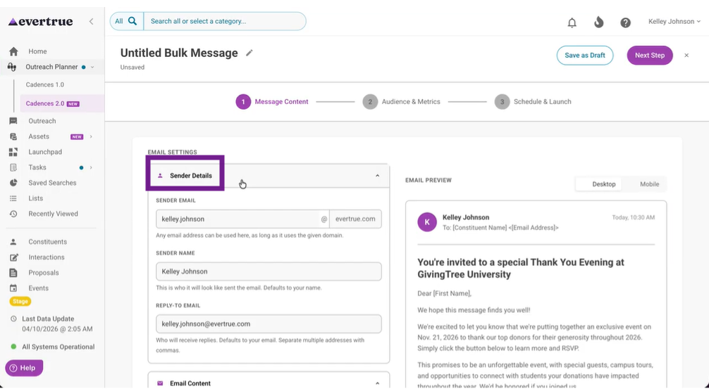

3. Insert an email template if needed
Open the Email Template Library and insert a saved template when you want to reuse approved or commonly used content. After inserting it, review and edit the message for this specific send.
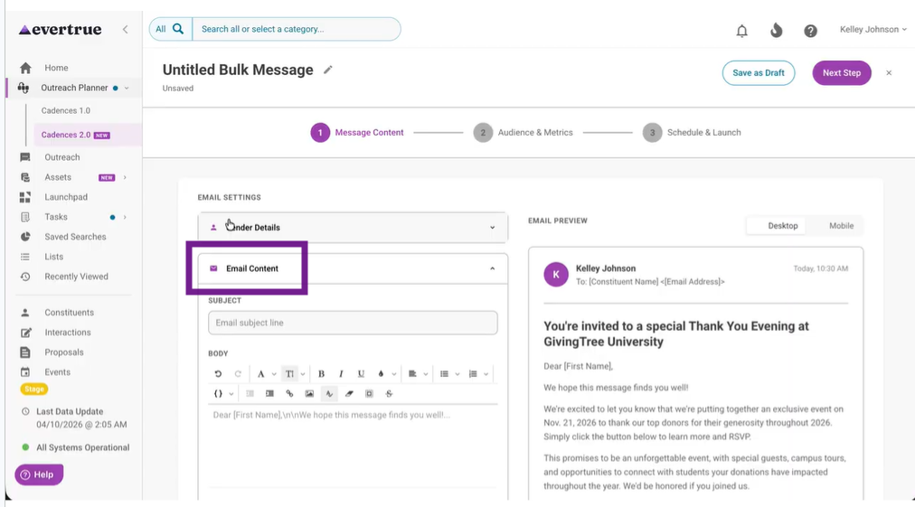
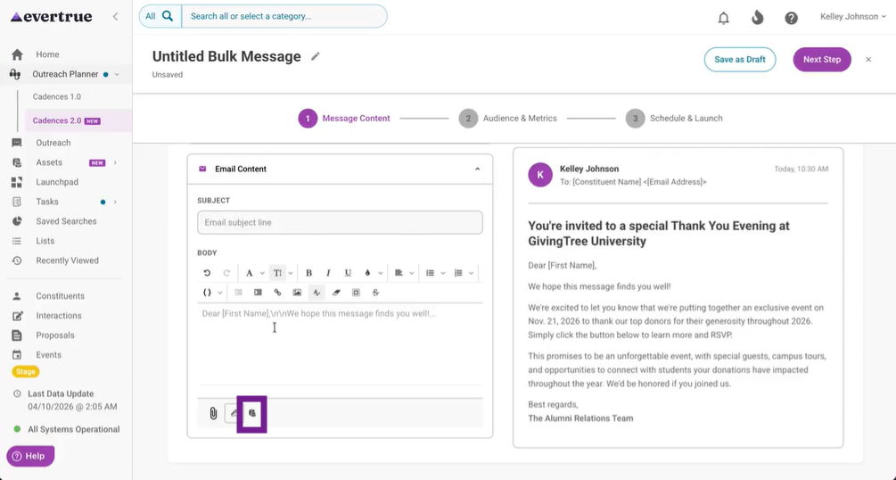
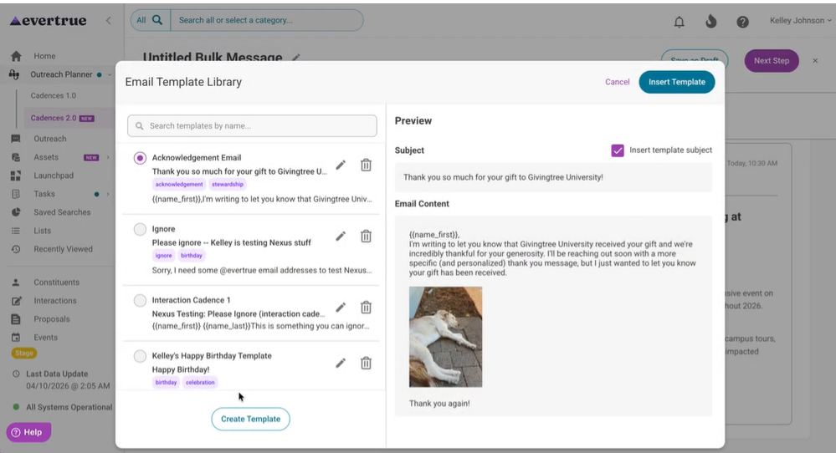

4. Preview the message
Review the subject line, body content, merge fields, sender details, and formatting before moving on. If desktop and mobile previews are available, check both.
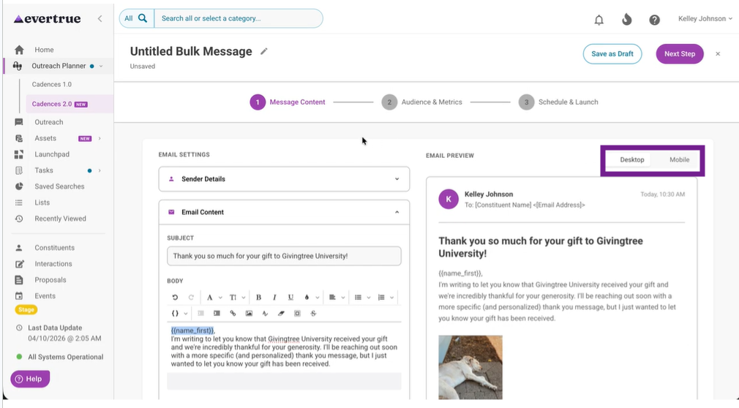

5. Choose the audience
Move to Audience and Metrics, then select the recipients for the bulk message. Confirm the recipients are correct before continuing. You can use a list, saved search or select contacts.
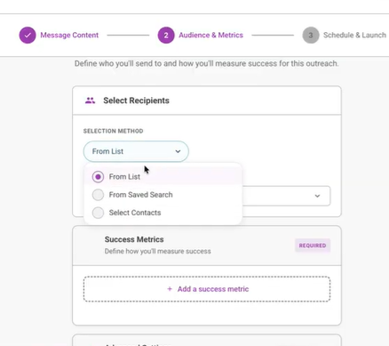

6. Choose the primary success metric
Select one required success metric that matches the real goal of the send, such as open rate, response rate, click rate, interaction created, gift given, portfolio stage reached, or saved search qualification.
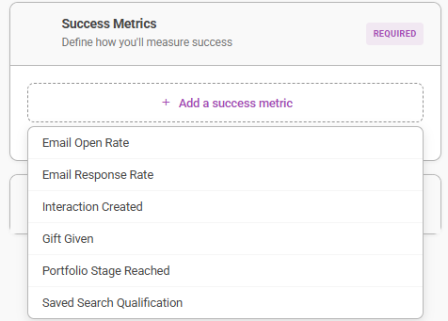

7. Review advanced settings
Check options such as sharing, linked proposals, cadence blueprint, tags, and blackout date behavior. Confirm whether the message should respect blackout dates and pauses. Learn more about advanced settings in the full video.
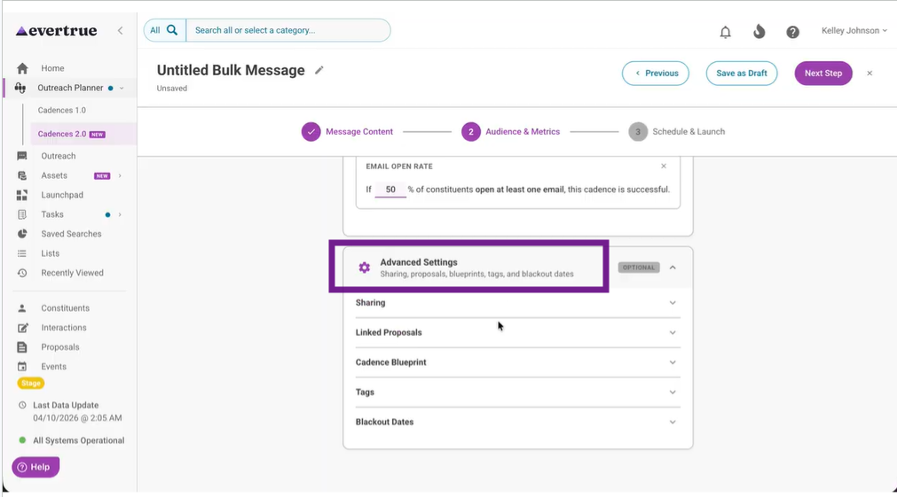

8. Send a test message
Use Test Send to verify formatting, personalization, sender details, and message content in a real email. If the workflow supports it, preview the message against a specific contact before sending the test to yourself.
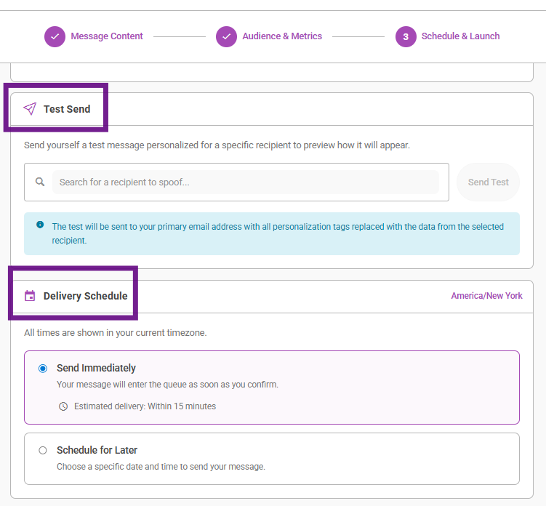

9. Choose Send Now or Schedule Send
Move to Schedule and Launch. Decide whether to send immediately or schedule the message. If scheduling is available, confirm the date, time, and timezone.

10. Launch the bulk message
Once the content, audience, metric, and settings are correct, launch the message. After sending, read the Review Bulk Message Performance and Recipient Status Help Article to monitor the success of your message.
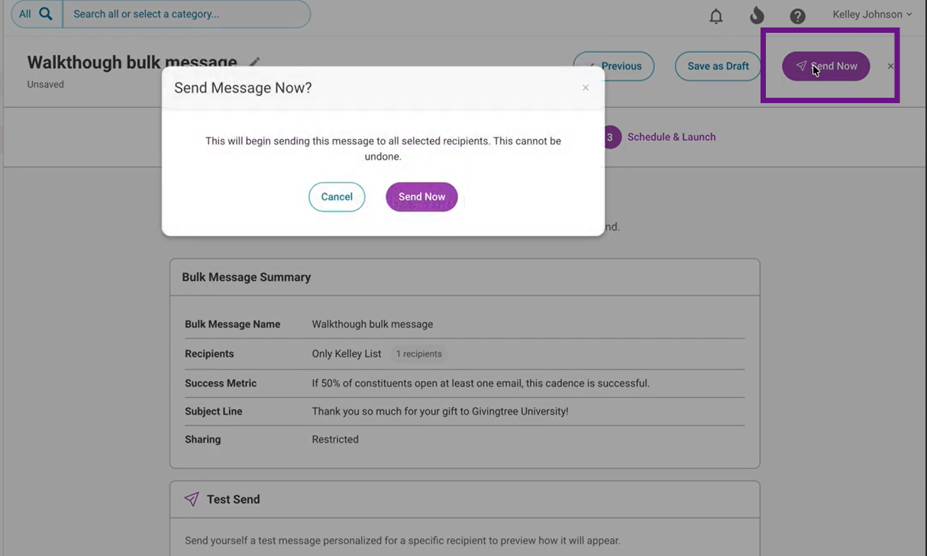

What users should know
- A bulk message is a one-time send, not a sequence.
- A primary success metric is required because the system uses it to judge whether the send met its goal.
- Templates save time, but the final message still needs a human review before launch.
- A test send is the quickest way to catch formatting or personalization problems before the full send.

Best practices
- Use a bulk message only when the content is mostly the same for everyone.
- Choose the success metric based on the real purpose of the outreach, not just the easiest metric to measure.
- Send a test before broad distribution, especially for high-visibility outreach.
- Double-check the audience before sending. That old habit prevents avoidable mistakes.

Troubleshooting
Issue | What to do
I cannot move forward in setup. | Check that the required fields are completed in the current step, especially message content, recipients, and the primary success metric.
I am not sure which success metric to choose. | Pick the metric that best reflects the real goal of the send. Use open rate for awareness, response rate for replies, click rate for traffic, and interaction-based metrics when follow-up action matters.
My message looks wrong in preview. | Review the subject line, formatting, merge fields, and inserted template content. Then send a test message before launching.
I used a template, but the message still needs edits. | That is normal. Templates are a starting point, not a finished send.
I am worried about timing. | Use Schedule Send and verify the date, time, and timezone before confirming.
I want to understand results after sending. | Use the bulk message detail page and the metrics article for post-send review.

Other Resources

Cadences 2.0 Glossary
Skip and Error Logic
Cadences Blueprint

